Qatar University

College of Engineering

Computer Science and Engineering Department Spring 2022 CMPS 351: Fundamentals of Database Systems

**Assignment-2**

Submission deadline: Monday, February 28th, 2022 (end-of-day, 11:59pm)

Start working on the assignment early. Avoid last minutes submissions. There will be 25% (per day) penalty for late submissions up to 2 days. No submissions will be accepted after Wednesday, March 2nd , 2022 (end-of-day, 11:59pm)

**Important Notes:**

1. Submit through Blackboard, **NO other means like email, etc., are accepted.**
2. Assignments are to be solved **individually**. You should **NOT** write-up solutions together NOR copy-and-paste solutions that are not YOURS.
3. Submit your work as instructed below ***before*** the deadline**.**

If you have any uncertainty, questions, or doubts about any of the above, ask your instructor!

**Honor Code Agreement**

**I understand that submitting work that is not my own will result in a “Zero” grade and in a disciplinary action**

**Name: Talha Abdullah**

**QUID: 201903446**

Carefully read your textbook, especially Chapter 5 and 8, then workout the following. To practice more, check the textbook exercises at the end of chapters.

1. Consider the following relations for a car-rental database application:

CUSTOMER(Customer_no, Customer_name, City)

RENTAL(Rental_no, Rental_date, Customer_no, Time, Date, Hourly_rate)

RENTAL_CAR(Rental_no, Car_no, Driver_no, Start_time, End_time, Amount_received)

CAR(Car_no, Year, Model, Price, Depreciation, Last_service)

SERVICING(Garager_no, Car_no, Service_date)

GARAGE(Garage_no, Garage_address, Owner_name)

DRIVER(Driver_no, Driver_name, Driver_address)

Here, Hourly_rate refers to the per hour rate for a specific rental. Amount_received is the total fare; Time and Date are the time and date when the car and driver is sent to the customer. Rental_date is the date the rental order was placed. Assume that a car can be driven by any driver and can go to more than one garage for servicing.

1. [**1 pts**] Identify what you think should be various candidate (**primary, and unique**) keys. Write in your own words the conditions or assumptions under which each candidate key would be valid.

Ans)

**1) Customer:** Customer_no should be the primary key as we want unique and NOT NULL values. Customer_name and City can have multiple values, so therefore there is no need of any constraints like primary or key constraints

**2) Rental:** Rental_no should be the primary key as we want the number to be unique and NOT NULL. Rental_date can be similar and thus, does not require any constraints. Similarly, Time, Date and Hourly_rate can have similar values and hence, do not require any constraints.

**3) Rental_car**: Start_time, End_Time, Amount Received can be similar as two customers can have the same values for each.

**4) Car:** Car_no can be the primary key as two cars do not have the same number plate. Model, Price, Depreciation, Last_service can be duplicated for different cars and hence, do not require constraints.

**5) Driver:** Driver_No can be the primary key while Driver_name and Driver_address can take multiple values and hence do not require constraints

**6) Garage:** Garage_No can be the primary key as the garage is identified through its unique number. Garage_address and Owner_name can have similar entries and thus, do not require constraints

**7) Servicing:** No need to have any constraint for the Service_date

1. [**2 pts**] Identify other constraints for this database? justify your answers.

Ans)

1. Customer_name cannot be null as we need to observe customer number along with customer name

2. Driver_name cannot be null as we reserve a driver name to a unique driver number

3. Car_No and Garage_No act as foreign keys in “Servicing”

4. Car_No, Rental_No, Driver_No act as foreign keys in “Rental_Car”

5. Service_Date must not be null as Last_Service in “Car” has to be calculated through this.

6. Time and Date must not be null in the “Rental” Table as we need to calculate Hourly_rate

1. [**2 pts**] Populate the relations with a few sample tuples, and then give examples of insertions that violate the constraints identified in (b).
2. Table Customer: t1<0, “Talha”,”Doha”>

t2<1, “Abdullah”,” Wakrah”>

t3<0, “Muhammed”,” wakrah”>

Here t3 violates the primary constraint with the same Customer_no value

1. Table Car: t1<132,2022,”XZ”,23245,Price-Price*0.5,12/3/2022>

T2<232,2021,”XY”,23214,Price-Price*0.4,12/4/2021>

Here Inserting a car with car_no as 232 will violate primary key constraint

1. Table Rental: t1<0,12/4/2021,0,10:30,12/3/2022,500>

T2<1,12/5/2021,3,12:30,15/4/2022,5000>

Here inserting customer_no as 3 will violate referential integrity constraint as no customer_no is 3 in the customer table

1. Table Rental_Car: t1<0,132,2,10:30,12:30,1000>

T2<2,153,10,12:30,6:30,5000>

Here inserting a tuple with Rental_no as 2 or Car_no as 153 or Driver_no as 10 will violate referential integrity constraint

1. Table Garage: t1<100, “Doha”,”Abdullah”>

T2<100, “Wakra”,”Abdullahi”>

Here inserting another tuple with garage_no as 100 will violate primary key constraint

1. Table Driver: t1<1, “Usama”,”Wakra”)

T2<1, NULL,”Wakra”)

Here inserting a tuple with driver_no as 1 will violate primary key constraint and no Driver_Name will give a no null constraint

1. Table Servicing: t1<100, 132,12/3/2021>

T2< 100, 142,NULL>

Here inserting a tuple with Car_no as 142 will violate referential integrity constraint while leaving the Last_service NULL will give us NO NULL Constraint

1. [**5 pts**] Write the following queries using **relational algebra** and (**tuple and domain**) **relational calculus** expressions:

* List all information about the cars that were serviced at the garage number ‘201’ on today’s date.

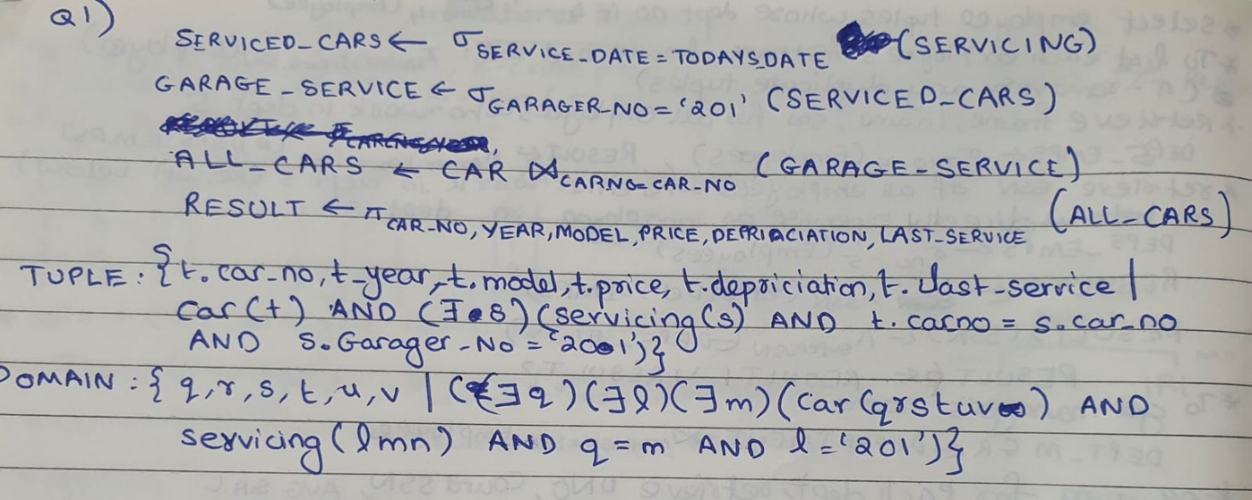

* List the RENTAL information about the rental services where the DRIVER named Mohamed Ali had provided service. Produce a listing: Rental_no, Car_no, Start_time, End_time and Amount_received.

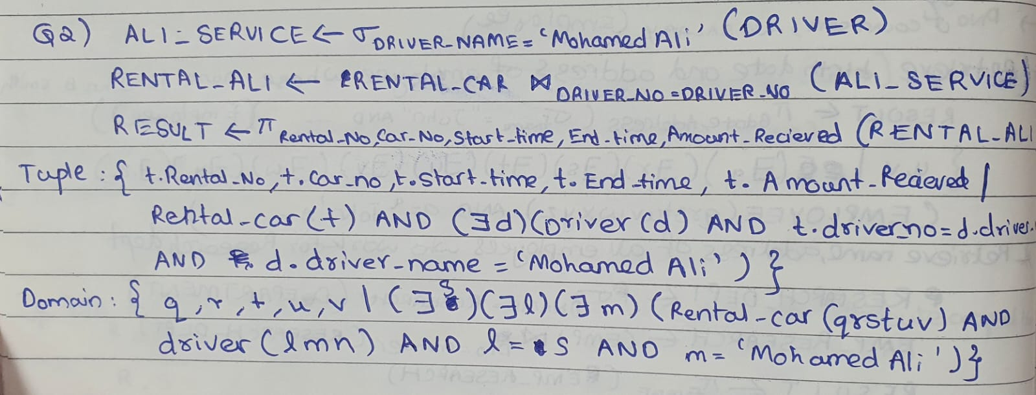

* Produce a listing Customer_name, No_of_rentals, Total_rental_amount, where the middle column is the total number of rental services taken by the customer and the last column is the total rental amount received for that customer.

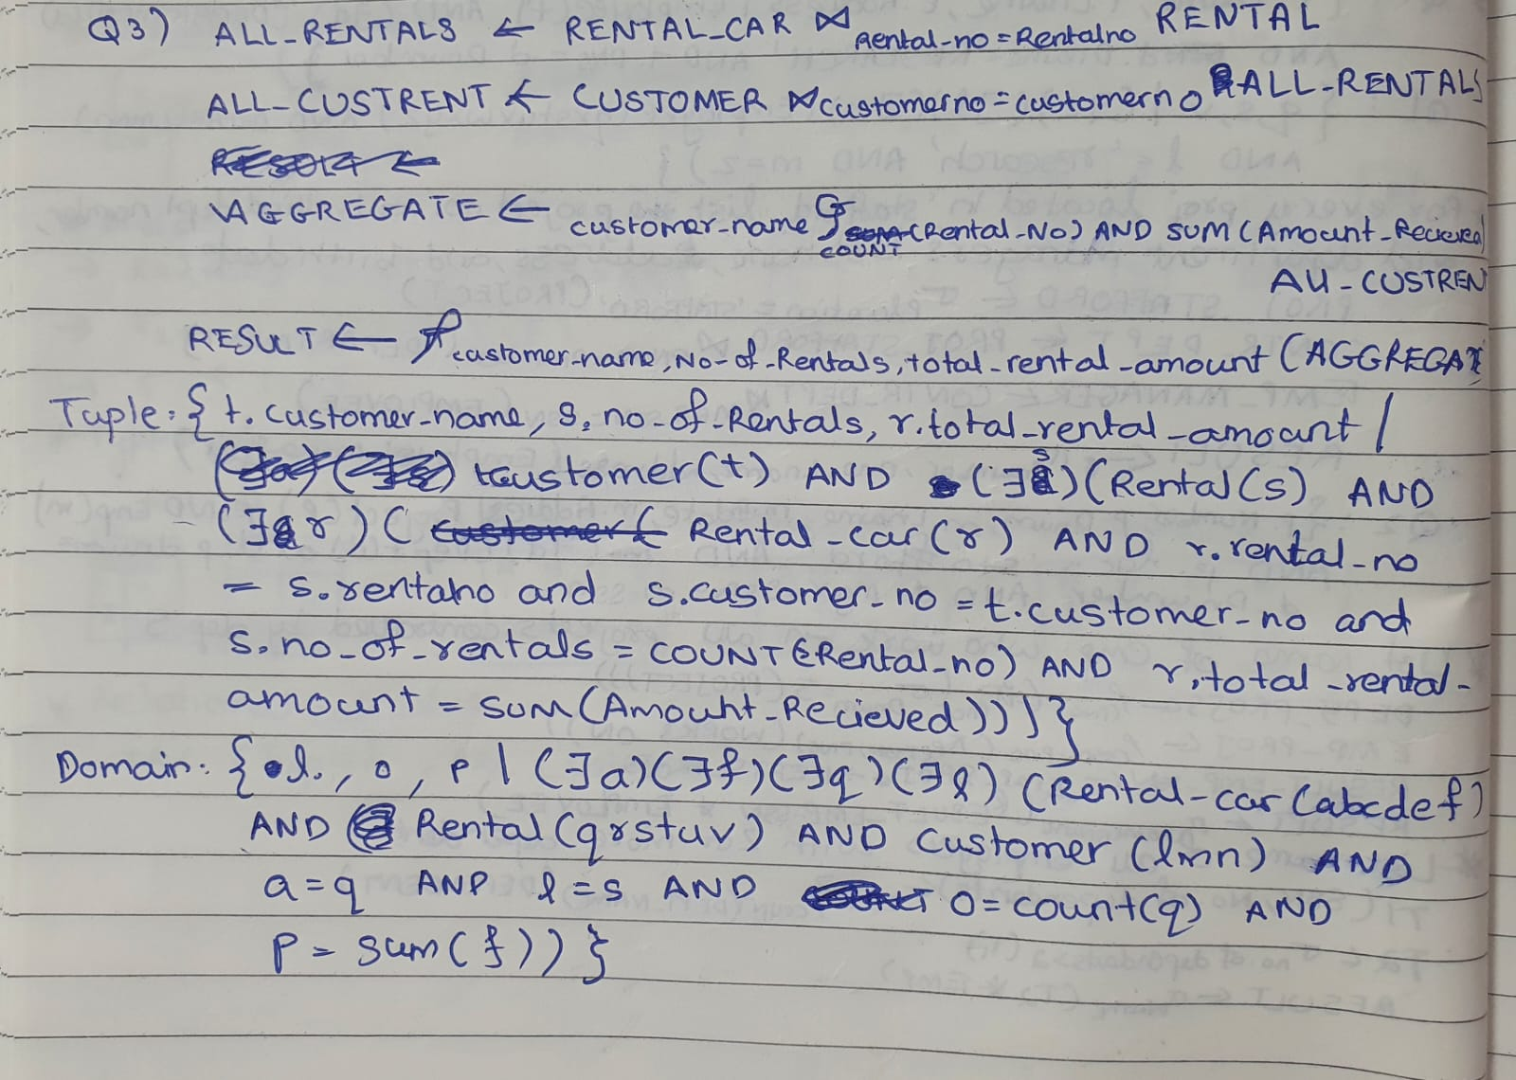

* List the rentals where the duration of service was more than 15 hours.

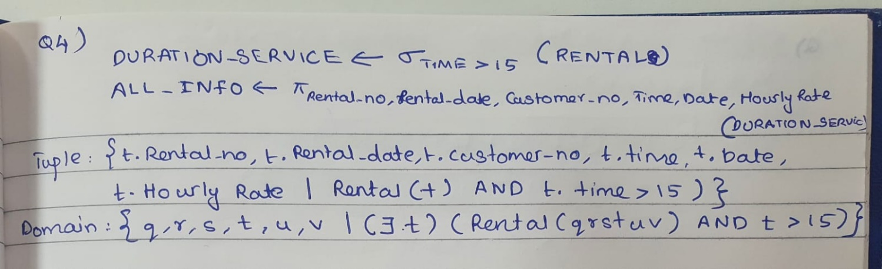

* List the driver number, names and addresses of all those drivers who are yet to be employed.

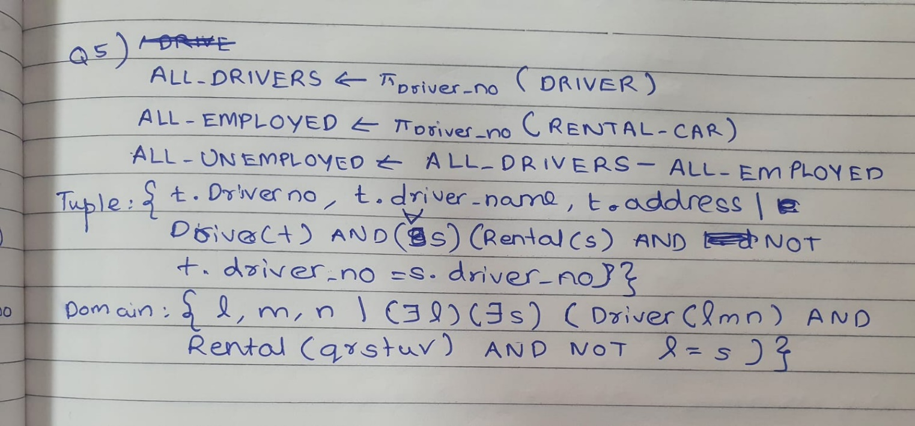

* **Notes:**
  + It is possible to specify the same query in multiple ways. So, give only one possible solution for each query, but with different languages.
  + You can use the symbols for the different operations as in Chapter 8 of the textbook or use the letter S for SELECT, P for PROJECT, J for JOIN, and F for FUNCTION.